Solution Name:- **Demo.TripService**

1. Demo.TripService.API :- Web API project which will Create and Get a trip and Save and fetch from the cosmos
2. Demo.TripService.Domain :- Holding Common model and Repositories services
3. Demo.Azure.Services :- Cosmos DB Generic methods
4. Demo.Trip.EventSender :- Window application which will raised the event
5. Demo.Trip.EventReciver :- Event listener and storage device vent into database
6. Demo.Azure.Services.Tests :- Unit Test project
7. Demo.TripService.API.Tests :- Unit Test Project

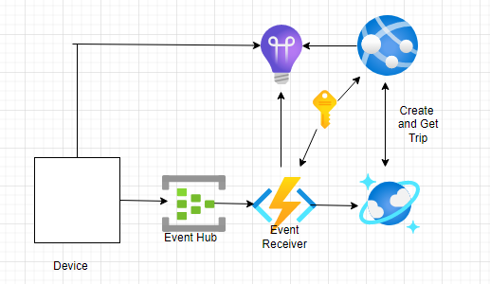

Flow :-

1. Create Trip :- Create Trip end point create a trip which will accept Trip Request input parameter and return trip Id.
2. Get Trip :- Return Trip details based on trip Id
3. Demo.Trip.EventSender :- pushing trip details into event hub
4. Demo.Trip.EventReciver :-Event hub trigger azure function read device event from event hub and stored into database
5. Get Trip :- UI will call after serval interval and display the coordinates

Note: - Challenges

1. Due to firewall issue on my machine unable to access azure service and end to end functionality testing